Safeguarding/Child Protection Policy

Our responsibility as an Early Years Provider is to ensure the safety and welfare of all the children in our care. This includes all mental and physical concerns. For example, we understand that children who have experienced adverse childhood experiences (ACEs) are vulnerable to mental health issues and other safeguarding concerns.
Erin Cuffley (Senior Manager), Amy Boennic (Chandler’s Ford Manager) and Amanda Brown (Romsey Abbey’s Manager) are appointed as the Designated Safeguarding Leads for Forest Footsteps Childcare. Additional members of staff are appointed as Deputy Safeguarding Leads (Hannah Smith and Yvonne Anderson).
As Safeguarding Leads, we will work in partnership with additional agencies to support the families we provide childcare for. We will liaise with Social Workers and Family Support Workers to ensure consistent and effective care for all the children. DSL’s will attend any safeguarding meetings such as Child in Need meetings and Child Protection conferences.
The Safeguarding Leads have access to, have read and will comply with, the guidance in the ‘Working Together to Safeguard Children - December 2023’ document, ‘Keeping Children Safe in Education - Sept 2024’, Childcare Act 2006, Children Acts 1989/2004, UNCRC, Neglect strategy, Counter Terrorism and Security Act 2015, Safeguarding Vulnerable Groups Act 2006, ‘Information Sharing – May 2024’, GDPR and Data Protection Act 2018 (replacement of the Data Protection Act 1998).

Designated Safeguarding Lead training is comprehensive and covers the following:
- How to take account of any advice from Hampshire Safeguarding Children Partnership (HSCP) or the Local Authority (LA) on appropriate training courses.
- How to build a safer organisational culture.
- How to ensure Safer Recruitment.
- How to develop and implement Safeguarding policies and procedures.
- How to support, work with and lead the team to safeguard children.
- Local Child Protection procedures and how to liaise with local statutory Children’s Services agencies and with the Hampshire Safeguarding Children Partnership to safeguard children.
- How to refer and escalate concerns including (taken directly from the EYFS), how we work with parents/carers to support their child’s development/wellbeing and how we check the suitability of people who work with children.
- How to manage and monitor allegations of abuse against those in a position of trust.
- How to ensure internet safety.

All staff have a statutory requirement to follow Safeguarding guidelines set out by the EYFS. All staff have attended training in Safeguarding/Child Protection, designed for adults caring for children aged 0-5 and for those older children attending our holiday club sessions too. The training covers:
- What is meant by the term Safeguarding.
- The main categories of abuse (Physical, Emotional, Sexual and Domestic), harm and Neglect. Also, additional abuses - including but not limited to - child on child abuse, forced marriage, online abuse and grooming, human trafficking, honour-based violence, breast ironing, bullying, cyber bullying, fabricated or induced illness, child sexual exploitation, female genital mutilation (FGM), cuckooing and county lines.
- The factors, situation and actions that could lead to - or contribute to - abuse, harm or neglect.
- How to work in ways that safeguard children from abuse, harm and neglect.
- How to identify signs of abuse, harm and neglect at the earliest opportunity - Significant changes in a child’s behaviour, deterioration in children’s general well-being, unexplained bruising/marks or signs of possible neglect or abuse, children’s comments or behaviour which gives cause for concern, any reasons to suspect neglect or abuse outside the setting (for example in the child’s home - witnessing domestic abuse, or that a girl may have been subjected to, or at risk of, FGM), inappropriate behaviour displayed by other members of staff, or any other person working with the children (for example: inappropriate sexual comments, excessive one to one attention - beyond the requirements of their usual role and responsibilities - or inappropriate sharing of images).
- How to respond, record and effectively refer concerns or allegations related to Safeguarding in a timely and appropriate way.
- Staff are trained in being aware of the vulnerability factors for some families and children as listed: Non-verbal children, Children with SEND/disabilities, looked after children and children whose parents may suffer with drug or alcohol addiction, domestic violence or mental illness.
- The setting’s policies and procedures of reporting to the Designated Safeguarding Lead.
- Legislation, national policies, codes of conduct and professional practice with regards to Safeguarding.
- Roles and responsibilities of adults and other relevant professionals involved in Safeguarding.

All staff, regular visitors or volunteers (over the age of 16) are enhanced DBS checked to ensure they are safe to be working with or around children. Staff DBS certificates, which are registered on the update service, (payable annually by the staff member) are regularly checked to ensure DBS’s are up to date. For staff not registered on the update service, they will be requested to apply for a new DBS every year, at their own cost.
If - when waiting for an initial enhanced DBS check - (applied for by Forest Footsteps Childcare), for an individual person to come through, they will not be left alone with the children and a risk assessment will be completed.
All staff (including bank staff) are employed following our Safer Recruitment and Employment Referencing Policy. If, in the rare event of requiring to use supply staff from an agency, we will ensure they have robust Safer Recruitment procedures in place too, ensuring the supply staff hold a recent enhanced DBS certificate.
Below are examples of good practice we follow to ensure the welfare of all the children:

- At all times, a minimum of one member of staff on the premises will hold a valid paediatric first aid (PFA) certificate. All staff who obtained a Level 2 or a Level 3 qualification since 30th June 2016, must obtain a PFA qualification within three months of starting work - in order to be included in the required staff:child ratios. To continue to be included in the ratio requirement, the certificate must be renewed every three years.
- We have a Professional Love Policy and Safe Touch (including Positive Handling) Policy and a Self-Regulation Policy in place. Within these, it states that corporal punishment will never be used.
- No smoking or vaping policy.
- No persons in the setting will be under the influence of drugs or alcohol.
- The Senior Manager/Owner and Ofsted Registered person has had a health declaration to ensure her suitability of working with children.
- Any persons who have access to the property, for example a tradesperson like a plumber, will not be left unattended with the children.
- Parents are to provide written information regarding any accidents/injuries that have happened away from the setting.
- Mobile phone, camera and use of technology policy is in place.
- We receive regular updates and attend appropriate training on safeguarding and child protection, including meeting the needs of children with special educational needs/disabilities and ‘child on child’ abuse.
- We regularly check the Hampshire Safeguarding Children Partnership website for changes and updates, including being subscribed to their email update service.
- We have displayed the appropriate Safeguarding posters on our parent notice board to give advice to anyone who wishes to raise a concern.

All safeguarding and child protection documents are kept in a secure filing cabinet. Documents are transferred with the child on transitions. The new setting (or school) will be required to sign to confirm receipt of these documents. Forest Footsteps Childcare may continue to store records if applicable, or if the child is not transferring to another setting/school - up to the age of 25 years old.

Covid-19
The lasting effects of the global pandemic are still being seen in families and in children’s development/wellbeing. Staff are aware to be mindful of identifying any concerns for individual children. These concerns could be, but not limited to:
- Mental health concerns.
- Witnessing Domestic Violence.
- Accessing inappropriate online games and websites.
- Subject to all forms of abuse.
- Subject to changes in their family life such as redundancies.
- Experience of death or illness within the family.
Where required, working arrangements with additional agencies (Area Inclusion team, the Local Authority and Children’s Services) will be in place to support the families due to lasting effects.

Looked After Children
At Forest Footsteps Childcare, we have a designated lead to liaise and support children and families of ‘Looked After Children’. Our Lead, Erin Cuffley will seek guidance and training from the Virtual School website to fulfil their role.
The setting’s DSL or Looked After Child Designated Lead will attend any CIN (Child in Need) or CP (Child Protection) conferences, including contributing to the child’s PEP (Personal Educational Plan).

Prevent Duty
The Counter Terrorism and Security Act 2015, places a duty on Early Years Childcare providers to report any concerns in line with our Safeguarding procedures that may arise, regarding children being drawn into terrorism. This new law is known as The Prevent Duty. This also involves ensuring we provide an environment that promotes British Values.
The four British Values are:
- Democracy
- The Rule of Law
- Individual Liberty
- Mutual respect and tolerance of different faiths and beliefs.

Referrals for any concerns related to PREVENT will be submitted using the following referral form:
https://documents.hants.gov.uk/community-support/PreventNationalReferralForm.pdf
Alternatively, any immediate concerns will be reported via 999.
We reserve the right to seek advice through Hampshire's Children Services as well.

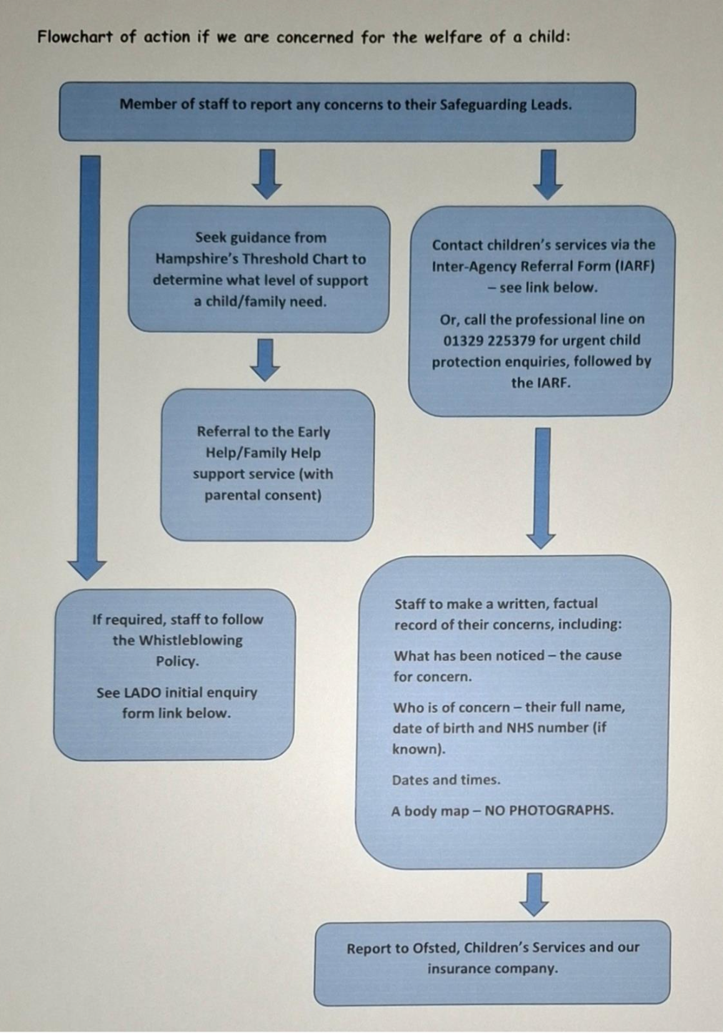

If we aware that FGM has taken place or have any concerns, we are required to report this directly to the Police

Inter-Agency Referral to Children's Services
Please be advised that all referrals to Children's Services must now be submitted via an Inter Agency Referral Form (IARF) https://childrenandfamiliesportal.hants.gov.uk/s4s/FormDetails/FillForm?formId=279
Members of public can contact Children’s Services to report any concerns to:
0300 555 1384 (or ‘Out of hours’ on 0300 555 1373).

Early/Family Help Referrals
Where we feel families will benefit from Early/Family Help support, we will make the referral using our local procedures.
To access Early/Family Help at Level 2, we will make a referral using the relevant referral form:
https://documents.hants.gov.uk/childrens-services/early-help/fss-level-2-referral-form-eastleigh.doc
For Level 3 Early/Family Help, we are required to complete the online Inter-Agency Referral Form to Children’s Services where they will assess the threshold level of concerns alongside the Multi-Agency Safeguarding Hub (MASH). On occasions where the MASH team feels that the referral requires higher support than Early/Family Help, Children’s Services will put the necessary procedures in place to safeguard a child.
Early/Family Help support can be for various concerns that are not urgent, such as and not limited to, housing, truancy from education, financial concerns and mental health concerns. A poster explaining more is displayed on our parent notice board but can also be accessed here:
chrome-extension://efaidnbmnnnibpcajpcglclefindmkaj/https://documents.hants.gov.uk/childrens-services/early-help/early-help-leaflet-digital.pdf

Early/Family Help contacts:
Eastleigh – eastleighWinchester.EH@hants.gov.uk
Test Valley – testvalley.earlyhelp@hants.gov.uk - 01962 846363

We will refer to the Hampshire Threshold Chart on the following link:
https://www.hampshirescp.org.uk/documents/hiow-thresholds-chart/

In all instances we will record:
- the child’s full name, date of birth and address.
- the date and time of the record.
- factual details of the concern (for example, bruising), what the child said, who was present and any previous concerns.
- details of any explanations from the parents.
- any action taken, such as speaking to parents.
- For all cases we will need to share information with relevant agencies. Confidentiality will be taken into account, ensuring information is shared only with relevant agencies taking guidance from the Information Sharing (July 2018) Document.

LADO (Local Authority Designated Officer)
The LADO will be advised of all cases where it is alleged that a person who works with children has:
- Behaved in a way that has harmed, or may have harmed, a child.
- Possibly committed a criminal offence against, or related to, a child.
- Behaved towards a child or children in a way that indicates they may pose a risk of harm to children.

We will seek advice before investigating or taking action against a member of staff, using the online initial enquiry form - https://forms.office.com/Pages/ResponsePage.aspx?id=tdiBPwfuF0yGnB20OQGNm3hCO_yf_9JNiASh9OheoihUQTlJRFM0SE0zUFE2Q1BPT0Y1SE5TTDMwVy4u
We will also contact the LADO if we have concerns about a person’s behaviour outside of the workplace which indicates that they pose a risk of harm to the children they work with. Emails can be directed to: child.protection@hants.gov.uk.
More information for the LADO can be found at: https://www.hants.gov.uk/socialcareandhealth/childrenandfamilies/safeguardingchildren/allegations

Escalation Procedure
Where we feel that a referral or concern that has been reported has not been taken seriously (or the case has been closed that we disagree with), we can start the Escalation Procedure. This is detailed in the flow diagram below:
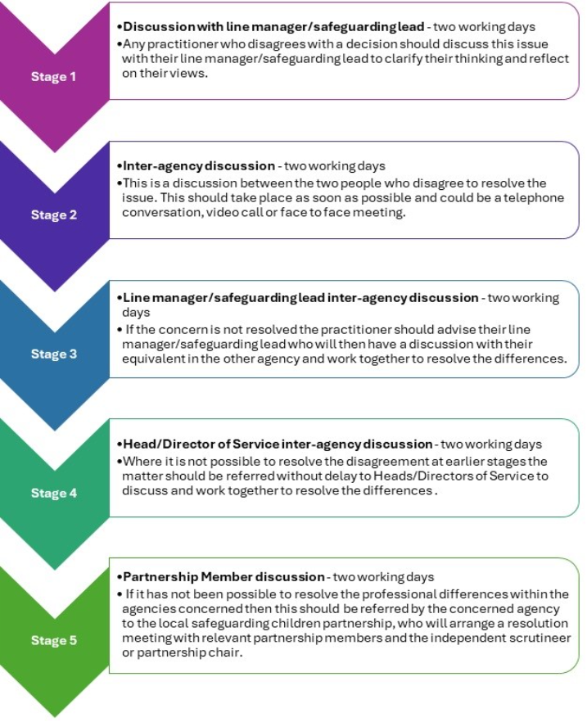

More details can be found at https://hipsprocedures.org.uk/skyyty/safeguarding-partnerships-and-organisational-responsibilities/professional-challenge-and-resolution-of-professional-disagreement

Other useful contacts:
Hampshire Safeguarding Children Partnership - https://www.hampshirescp.org.uk/
NSPCC – 0808 800 5000
Women’s Aid - 0808 2000 247
Hampshire Constabulary – 0845 045 4545
https://hipsprocedures.org.uk/
https://www.hampshirescp.org.uk/parents-and-carers/organisations-that-can-help/
https://napac.org.uk/
For free access (with no threshold advice), support and guidance from an Education Psychologist about how best to support your children - or for an individual child living with Domestic Abuse or other trauma - just phone 0204 513 9990 between 8am and 1:00pm.

